CROP DEAL

# LOW LEVEL DESIGN

1. ****DOCUMENT PURPOSE****

**This document give the complete description of the processes and resources used for developing the solution of Crop Deal system.**

1. ****PROJECT BACKGROUND****

This Crop Deal project focus on providing online platform to farmer and dealer where they can but and sell crops without and intermediate person . Thus reducing the price and buiding a new farmer and dealer relation.

1. **PROJECT OBJECTIVE**

Crop Deal system provide farmer to upload his details , list crops for selling . address and bank details.

The dealer can view list of crops , make purchases and generate a invoice according to the purchase.

1. **DESIGN PATTERN**

|  |  |  |
| --- | --- | --- |
| **NO.** | **Name** | **Description** |
| **1** | **API** | **Using HTTP requests, we will use the respective action to perform various crud operations.** |
| **2** | **HTML,CSS,BOOTSTRAP** | **Design the UI for the user.** |
| **3** | **ANGULAR** | **Connecting the UI frontend with the backend API.** |

1. 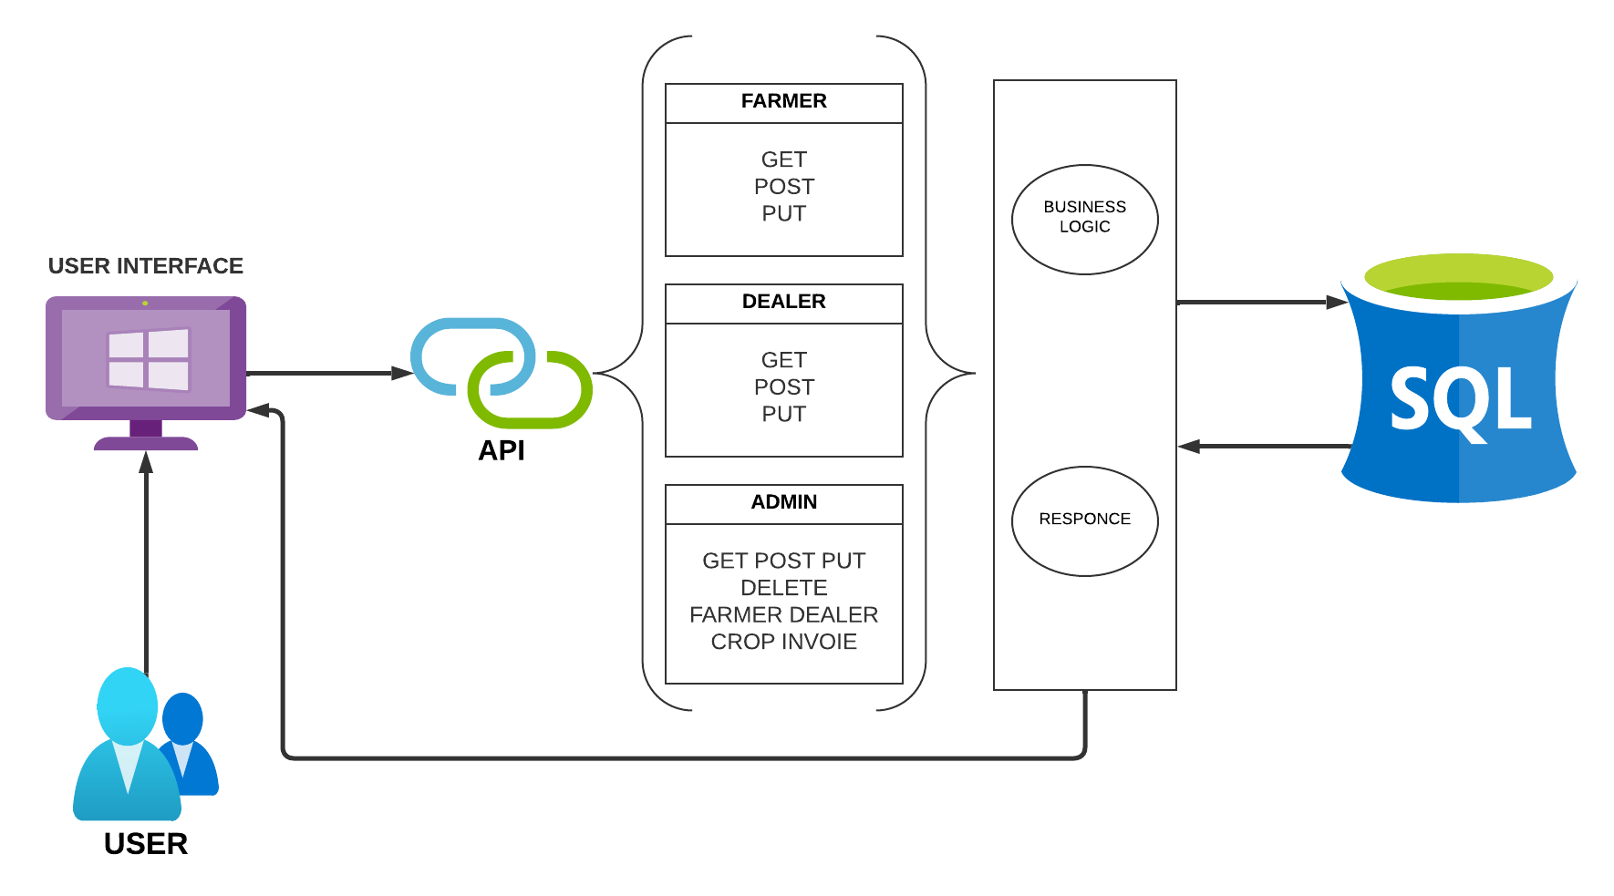**SOLUTION DIAGRAM**

**FARMER:-**

* **ADD CROP**
* **EDIT CROP**
* **DELETE CROP**
* **EDIT PROFILE**

**DEALER:-**

* **VIEW CROP**
* **SUBSCRIBE CROP**
* **BUY CROP**
* **EDIT PROFILE**

**ADMIN:-**

* **ADD/EDIT FARMER**
* **ADD/EDIT DEALER**
* **ADD/DELETE CROP**
* **VIEW ALL INVOICE**

1. **CLASS DIAGRAM**

|  |  |  |
| --- | --- | --- |
| **CLASS NAME** | **ATTRIBUTE** | **CLASS PROCESS** |
| ADMIN | ID,EMAIL,PASSWORD | Admin can add/delete profile, add/delete crop, view all invoice and generate report |
| FARMER/DEALER | ID ,NAME,EMAIL,PASSWORD,  CONTACT,ADDRESS | User can edit their profile, farmer and post crops and dealer can buy the crops. |
| CROP | ID,NAME,TYPE,QUANTITY,  PRICE,FARMER ID | Store crop details. |
| INVOICE | AMOUNT , DATE CROP ID,  FARMER ID, DEALER ID | Generate invoice and store it in database |

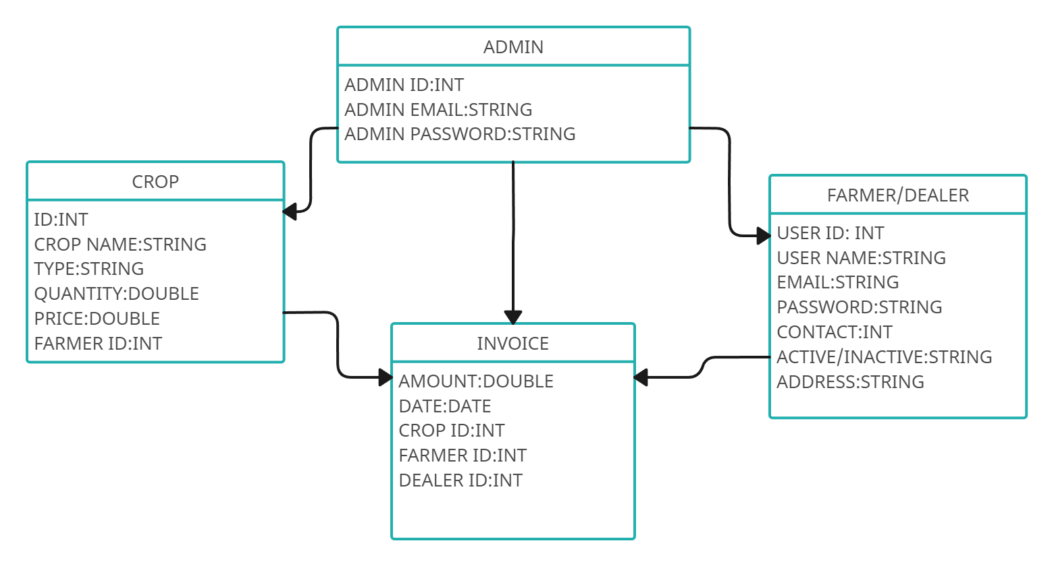

1. 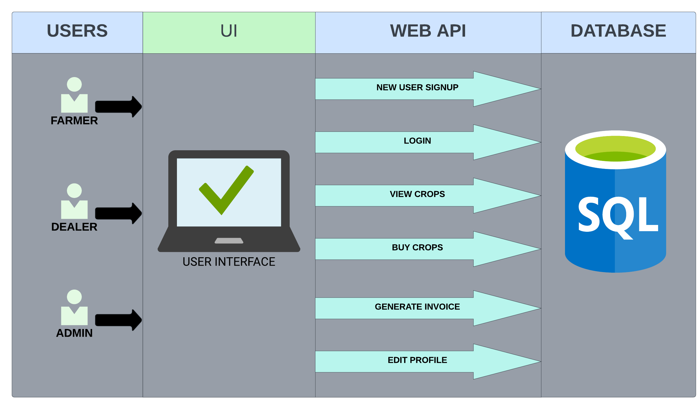**ARCTECTURE DIAGRAM**
2. **USE CASE DIAGRAM**

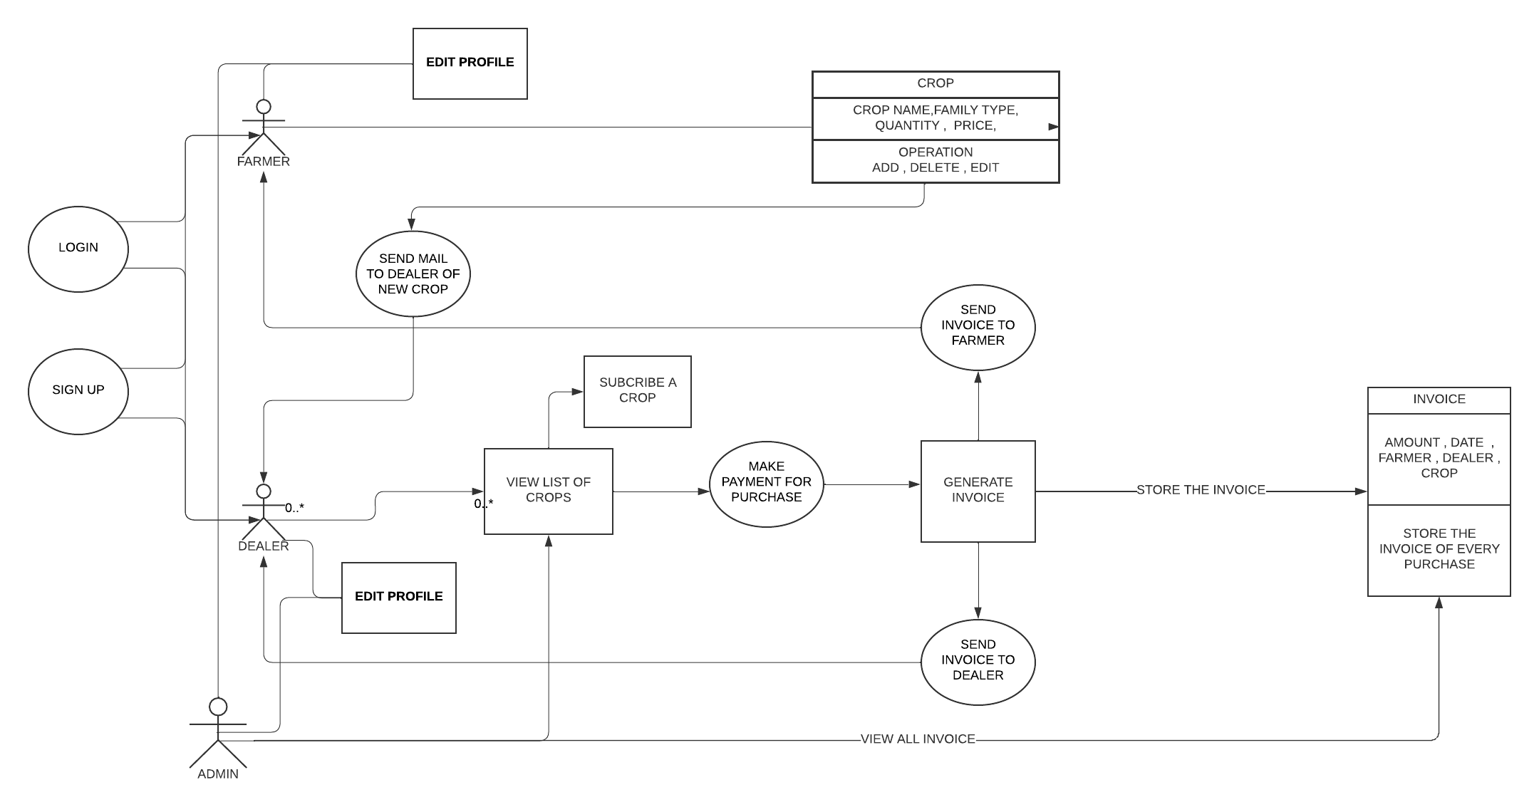

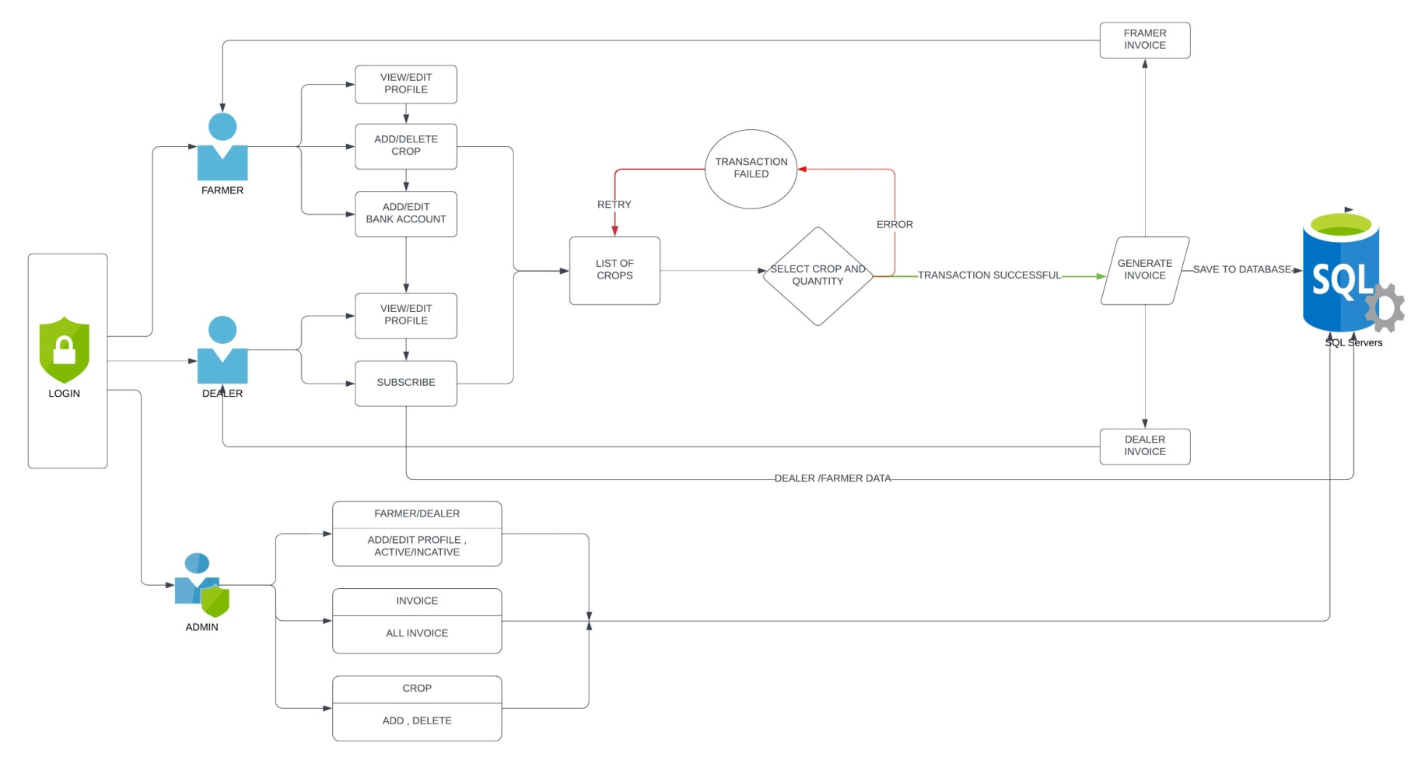**9.0 FLOW DIAGRAM**

**10.0 DATA MODEL DIAGRAM**

